Air pollution: trends and best practices from local to global scales

Benjamin W. Abbott, Isabella M. Errigo, Derrek Wilson, Andrew Follett, Sayedeh Sara Sayedi

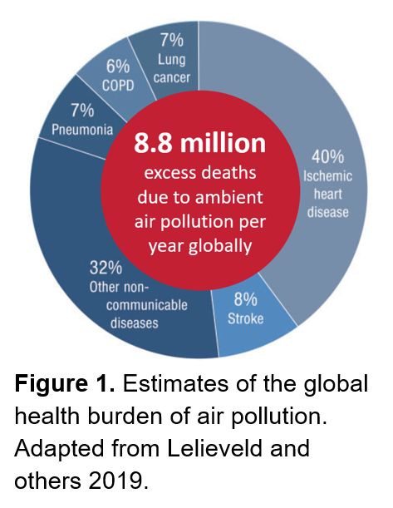Recent medical and economic research has found that air pollution causes much more damage to our health and economy than previously understood. Worldwide, more than 6% of all deaths are attributable to air pollution—at least 8.8 million people each year. That is 15 times more deaths each year than caused by all wars and acts of violence and 3 times more than caused by tuberculosis, malaria, and AIDS combined. Globally, the economic damage of air pollution exceeds $5 trillion—more than 7% of the global gross domestic product. Despite these staggering costs, air pollution does not receive the attention or funding given to many other problems that are objectively less grave. Here, we summarize the current literature on air pollution costs, changes through time, and policy approaches that have been effective and counterproductive. We focus on the U.S. but include research from around the world to address the following questions: 1. How much uncertainty is there in estimates of the health and economic costs of air pollution (i.e. do we have an adequate grasp of the scope of the problem), 2. What are the trends for the most damaging air pollutants at global, national, and local scales, 3. What general approaches have yielded the greatest return on investment, and 4. What specific obstacles have been encountered by municipalities, states, nations, and international groups as they work to improve air quality? We found that in the U.S. alone, air pollution causes the premature deaths of 100,000 to 300,000 people each year and costs at least $886 billion annually. Air pollution in the U.S. comes mainly from fossil fuel use, which creates toxic combustion products including particulate matter, ozone, and oxides of nitrogen, sulfur, and carbon. Many independent economic analyses have shown that improving air quality substantially stimulates economic growth across sectors while also addressing other environmental issues such as climate change. For example, the Clean Air Act of 1970 was followed by a decrease of 68% in common air pollutants while the U.S. Gross Domestic Product grew by 212%. More recently, the direct and indirect benefits of the 1990 Clean Air Act Amendment have added at least $2 trillion to the U.S. economy (an average of $65 billion each year), representing a return on investment of $32 for every $1 of cost. There is widespread evidence that politicians and the public do not understand these health and economic impacts, instead blaming many of these issues on unrelated causes. Approaches that simplify air quality into colors or imply that regulatory thresholds are biologically meaningful can obscure the scope of the problem and encourage apathy. Conversely, emphasizing high-resolution monitoring, continuous exposure factors, and quantitative trends can improve understanding and the rate of improvement.